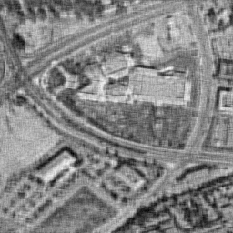
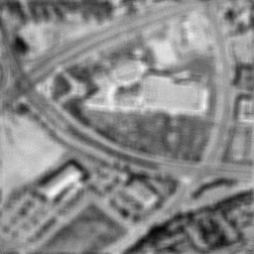

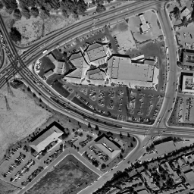

Image Restoration Using Wiener Filtering

Justin Ford

Isaac Gerg

May 3, 2004

Introduction
In our project we investigated image restoration using optimal Wiener filtering. To test our algorithm we intentionally degraded images and then used Wiener filtering to try to restore the original image. The algorithm we used operated in the frequency domain on the power spectrum of the degraded image. We assumed that we have knowledge of the point spread function for the blur operation as well as some statistical information about the additive noise. We implemented the algorithm in MATLAB. Our implementation is dependant on the MATLAB Fourier Transform function. We found that we were able to produce results that were as good as those given by Gonzales and Woods, our primary source for the algorithm we used.

Theory

Image Degradation

The degradation of an image can be modeled as a blur function and additive noise. There are many different blur functions and various types of additive noise that can corrupt an image. Common blurs include motion blur and Gaussian blur. Additive noise is usually white, and often has a uniform or Gaussian distribution. Figure 1 shows the image degradation model explored in this project. The input image, i(x,y) passes through a blur function and has noise added to it.

Figure 1 – Block Diagram, adapted from Pratt, 2001

The block diagram for the blur and additive noise can be written as an equation:
$$i_{D}(x,y)=i(x,y)∗h_{B}(x,y)+n(x,y)=H\vec{i}+\vec{n}$$
The degraded image is the original image convolved with the impulse response of the filter, then noise is added. The two dimensional convolution can be represented as matrix multiplication. The matrix H represents the blur function and is dimension MNxMN. The vectors i and n are “stacked” such that the first N elements of i are from the first row of I(x,y) and the next N elements are from the second row of I(x,y), and so on for all M rows of I(x,y) (Gonzales, 1992).
$H=\left[\begin{matrix}H_{0} & H_{M−1} & ⋯ & H_{1} \\ H_{1} & H_{0} & ⋯ & H_{2} \\ ⋮ & & & \\ H_{M−1} & H_{M−2} & ⋯ & H_{0}\end{matrix}\right]$ $H_{i}=\left[\begin{matrix}h_{B}(i,0) & h_{B}(i,N−1) & ⋯ & h_{B}(i,1) \\ h_{B}(i,1) & h_{B}(i,0) & ⋯ & h_{B}(i,2) \\ ⋮ & & & \\ h_{B}(i,N−1) & h_{B}(i,N−2) & ⋯ & h_{B}(i,0)\end{matrix}\right]$
The matrix H has a circular property as result of an assumption of periodicity for the image (periodic in M in the x direction and N in the y direction). This so called circulant matrix structure (the H_{i} matrices are circulant, H is actually block circulant) can be exploited to reduce the computational complexity of estimating the original image from the degraded image (Gonzales, 1992). Note that for a 256x256 input image, the H matrix is 65,535x65,535. To solve for i from i_{D}, 65,535 simultaneous equations must be solved.
We begin by performing eigen decomposition on a circulant matrix H_{i}:
$H\vec{w}(k)=λ(k)\vec{w}(k)$ where $\vec{w}(k)$ is the k^{th} eigenvector and $λ(k)$ is the associated eigenvalue, k=0,1,…M-1.
$λ(k)=h_{B}(0)+\sum_{i=1}^{M−1}{h_{B}(M−i)e^{j\frac{2π\text{ik}}{M}}}$ and $\vec{w}(k)={\left[\begin{matrix}1 & e^{j\frac{2πk}{M}} & e^{j\frac{4πk}{M}} & ⋯\begin{matrix} & \end{matrix}e^{j\frac{2π(M−1)k}{M}}\end{matrix}\right]}^{T}$
A matrix with the eigenvectors as columns can be formed, as well as diagonal matrix that has the eigenvalues on its diagonal (Gonzales, 1992):
$W=\left[\begin{matrix}e^{j\frac{2π}{M}} & e^{j\frac{4π}{M}} & ⋯ & e^{j2π} \\ e^{j\frac{4π}{M}} & e^{j\frac{8π}{M}} & ⋯ & e^{j4π} \\ ⋮ & & & \\ e^{j2π} & e^{j4π} & ⋯ & e^{j2Mπ}\end{matrix}\right]$, $W(i,j)=e^{j\frac{2π}{M}\text{ij}}$and $D_{i}=\left[\begin{matrix}λ(1) & 0 & ⋯ & 0 \\ 0 & λ(2) & ⋯ & 0 \\ ⋮ & & & \\ 0 & 0 & ⋯ & λ(M)\end{matrix}\right]$
The symmetry of W is apparent, and if W⁻¹ exists then all eigenvectors are linearly independent. This is assumed to be the case for our purposes. If W is not invertible, then a pseudo inverse or other method would be required. With W⁻¹,
However, H_{i} is only a circulant matrix and the matrix H is block circulant. A closer inspection of W reveals that the complex exponentials which comprise it are representative of the Discrete Fourier Transform (DFT). We know that H is composed of MxM H_{i} matrices, each of which is NxN giving the full MNxMN dimensionality. Essentially, H is circulant matrix with elements that are each circulant matrices themselves. To obtain the (i,j) element of H, we simply apply the above transform twice (Gonzales, 1992):
$W(i,j)=e^{j\frac{2π}{M}\text{ij}}W_{N}$ with $W_{N}=\left[\begin{matrix}e^{j\frac{2π}{N}} & e^{j\frac{4π}{N}} & ⋯ & e^{j2π} \\ e^{j\frac{4π}{N}} & e^{j\frac{8π}{N}} & ⋯ & e^{j4π} \\ ⋮ & & & \\ e^{j2π} & e^{j4π} & ⋯ & e^{j2Nπ}\end{matrix}\right]$
We again assume the existence of W⁻¹, and write $H={\text{WDW}}^{−1}$ where D corresponds to the DFT of h_{B}, so more importantly, $D=W^{−1}\text{HW}$

Wiener Filter
The degraded image, i_{D}(x,y), along with the Power Spectral Density of the blur function and the noise variance are passed to the restoration filter. Using the blur PSD and knowledge of the noise, the restoration filter estimates the original input image, i(x,y).
It is possible to arrive at an optimal solution using the method described above. In general, statistical estimators seek to minimize some criterion like Mean Square Error. Another common estimator is least squares, which seeks to minimize $||Q\hat{i}||$, Q being a transformation matrix and i hat being an estimate of the original image. The optimal i hat is found by using Lagrange multipliers (Gonzales, 1992):
$F(\hat{i})=||Q\hat{i}||+α(||i_{D}−H\hat{i}||^{2}−||n||^{2})$ where i sub D is the degraded image and α is a Lagrange multiplier. The required minimization is achieved where the derivative is zero:
$$\frac{∂F(\hat{i})}{∂\hat{i}}=2Q^{T}Q\hat{i}−2{αH}^{T}(i_{D}−H\hat{i})=0⇒\hat{i}=(H^{T}H+\frac{1}{α}Q^{T}Q)^{−1}H^{T}i_{D}$$
When α=1 the MSE $E\left\{[i(x,y)−\hat{i}(x,y)]^{2}\right\}$ is minimized and the Wiener solution can be obtained (Gonzales, 1992).
Typically, the estimator will employ some statistical properties of the signal, often extracted from an estimate of its autocorrelation, to improve the resulting estimate of the signal itself. The Wiener filter begins thus:
$R_{i}=E\left\{{\text{ii}}^{T}\right\}$ and $R_{n}=E\left\{{\text{nn}}^{T}\right\}$ are the autocorrelation matrices for the image and noise, respectively.
Since the image and noise are real valued, the autocorrelation matrices are symmetric. In a typical image, the correlation between pixels does not extend much beyond a distance of 30, so a typical correlation matrix has values clustered about the diagonal and zeros in the upper left and lower right corners (Gonzales, 1992). This allows for the approximation of the autocorrelation matrices as block circulant and we can apply the transform developed above:
$R_{i}={\text{WAW}}^{−1}$ and $R_{n}={\text{WBW}}^{−1}$
As developed above, A and B represent DFTs. Since R_{i} and R_{n} are correlation matrices, A and B are power spectrums of the image and noise, respectively. To obtain the Wiener filter, we select the transformation matrix defined above as (Gonzales, 1992):
$Q^{T}Q=R_{i}^{−1}R_{n}$ and then use the minimal i hat solution:
$\hat{i}=(H^{T}H+\frac{1}{α}R_{i}^{−1}R)^{−1}H^{T}i_{D}$, we now use $H={\text{WDW}}^{−1}$, $R_{i}={\text{WAW}}^{−1}$ and $R_{n}={\text{WBW}}^{−1}$
$$\hat{i}=({\text{WD}}^{}W^{−1}{\text{WDW}}^{−1}+\frac{1}{α}{\text{WA}}^{−1}W^{−1}\text{WBW})^{−1}{\text{WD}}^{}W^{−1}i_{D}=({\text{WD}}^{}{\text{DW}}^{−1}+\frac{1}{α}{\text{WA}}^{−1}\text{BW})^{−1}{\text{WD}}^{}W^{−1}i_{D}$$
Note that the transpose operator on H causes D to be conjugated since it contains complex exponentials and reciprocating is equivalent to conjugating.
$$W^{−1}\hat{i}=(D^{}D+\frac{1}{α}A^{−1}B)^{−1}D^{}W^{−1}i_{D}$$
In this form we see the W operator obtaining the DFT of the restoration estimate i hat and the degraded image. We know D, A and B are already DFTs. We also know α=1 for the Wiener filter solution. Therefore, this equation is a frequency domain representation of the filter solution:
$$\hat{I}(u,v)=\frac{H^{}(u,v)I_{D}(u,v)}{H^{}(u,v)H(u,v)+\frac{N(u,v)}{I(u,v)}}=\frac{H^{}(u,v)I_{D}(u,v)}{|H(u,v)|^{2}+\frac{N(u,v)}{I(u,v)}}$$
Of course, in practice, it is not necessary to estimate the degraded image i hat when i itself is known. Therefore, the ratio of the noise and image power spectra are usually estimated by a constant, K. This gives the final form of the Wiener filter in the frequency domain:
$$\hat{I}(u,v)=\frac{H^{}(u,v)I_{D}(u,v)}{H^{}(u,v)H(u,v)+K}$$
In our experimentation, we followed the suggestion of Gonzales and Woods to take K=2σ² where σ² is the variance of the noise. This generally yielded good results.

Implementation
The algorithm was implemented using MATLAB. All the images considered are assumed to be normalized and on the interval [0, 1].
A function was created that performed Wiener filtering on a degraded image. This function has the following prototype:
wienerFilter ( I, PSF, UI, N, LAMBDA )
where I is the degraded image, PSF is the point spread function, UI is the undegraded image, N is the noise matrix, and LAMBDA is a parametric factor.
I, UI, N, and PSF are matrices and LAMBDA is a scalar. The noise matrix is a matrix of values to be added to the undegraded image, UI. Thus, $I_{\text{Degraded}}=I_{\text{Undegraded}}∗\text{PSF}+N$. The PSF was created using MATLAB’s fspecial function. The power spectrums of the noise and image were created by the following equations:
$$\begin{aligned}S_{f}(u,v)={\left|ℑ\left\{I\right\}\right|}^{2} \\ S_{η}(u,v)={\left|ℑ\left\{N\right\}\right|}^{2}\end{aligned}$$
The Wiener filter function operates in the frequency domain following the equation:
$$\hat{F}(u,v)=\left[\frac{H^{}(u,v)}{|H(u,v)|^{2}+λ\left(\frac{S_{η}(u,v)}{S_{f}(u,v)}\right)}\right]I_{\text{Degraded}}(u,v)$$
where $H(u,v)=ℑ\left\{\text{PSF}\right\}$
Note that for the Wiener filter, LABMDA is always equal to one. This is done in all the examples shown in this paper. With the presence of LAMBDA, the Wiener filter becomes the so-called “Parametric Wiener Filter.” (Gonzales, 1992)
In the Wiener filter function described above, the power spectrums of the undegraded image and noise are calculated within our created wienerFilter function. Then, these values are plugged into the Wiener filter equation and a filtered image is returned. In the case where the undegraded image and noise are not known and are approximated by the constant K, UI is set to one and N becomes K, a scalar.
For example, there is a degraded image I degraded by a point spread function matrix, PSF. The noise is unknown and so is the undegraded image. This information is modeled as a constant, K. The wienerFilter function call becomes:
wienerFilter ( I, PSF, 1, K, 1 )
For comparison against the inverse filter, the noise parameter of the function can be simply set to zero. This will degrade the Wiener filter to the simple inverse filter. An example of this:
wienerFilter ( I, PSF, 1, 0, 1 )
will perform inverse filtering.

Results
The examples presented in this paper were generated via MATLAB script. The entire generated data set is available online at: http://www.personal.psu.edu/idg101/cse585/finalpj/. The images are placed in directories according to the type of additive noise used in their degradation. The images are named according to their blur type followed by their associated noise variance or interval. We generated results using three different blur types:
- Motion blur of length 10 pixels at an angle of –45 degrees relative to the horizontal.
- Gaussian blur with an 11 x 11 pixel mask with standard deviation 0.9.
- Averaging with a 7 x 7 pixel mask.
Each of the degraded images also has additive noise injected into them. We used two different noise types:
- Gaussian noise with variances 0.001, 0.01, and 0.05 with mean 0.
- Uniform noise on the intervals of [0, 0.001], [0, 0.01], and [0, 0.05]
Note that the matrices I, UI, N must all be of the same size. PSF does not need to be zero-padded as the function will take care of this.
The Wiener filter was examined using additive Gaussian noise and uniform noise with different parameters. These results are compared to simple inverse filtering. Heavily noisy and blurry images were also presented to study how the Wiener filters breaks down. Our results depicted the Wiener filter performing similarly for both noise types, Gaussian and uniform.
Even in the presence of little noise, the inverse filter quickly fails (Figure 4). Quickly analyzing the inverse filter shows that in the presence of noise, the noise term quickly explodes resulting in a useless image. Below are shown the wheel image degraded by a 11x 11 Gaussian blur with variance and Gaussian noise with variance 0.001.
  Figure 2 – Original image. | 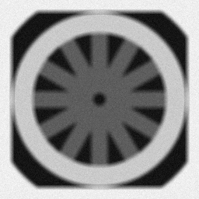  Figure 3 – Degraded Image. Degraded by 11x11 Gaussian mask with variance 1 and additive Gaussian noise with variance 0.001. |   Figure 4 – Inverse filtered image. | 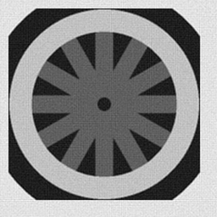  Figure 5 – Wiener filtered image.
Even for the low variances, the image is hidden by a “curtain” of noise. With the lowest variance depicted, the image looks as if there is little noise in it (Figure 3). However, notice there is an appearance of a bounding box around the original wheel image which is normally not present. For the higher variances, the filter quickly fails. It is difficult, if not impossible, to determine any features from the filtered image. This is an interesting fact considering that more features are realizable in the degraded image than the restored.
Wiener filtering on the wheel image restores the image much closer back to the original (Figure 5). However, even with low variance noise, the image cannot be fully restored. Notice there is a bounding box of noise around the restored images. Also, filtering artifacts are very prevalent around the edges in the image. As we will see, this is not so visible in photographic images.
Next, the Wiener filter is used on a photographic image. The image is degraded in the same manner as the wheel image. Even with this fact, it is somewhat difficult to see in some cases the effect the blur and noise has on the image. Despite this, the inverse filter still quickly degrades as it did in the last example. The table below (Table 1) depicts the results for a blur via 7x7 average mask with additive Gaussian noise.

Table 1 – A degraded image and its restoration comparison between inverse filtering and Wiener filtering. The degraded images were blurred with a 7x7 average mask along with Gaussian additive noise with the variances listed.
Variance | 0.001 | 0.01 | 0.05
Degraded Images | 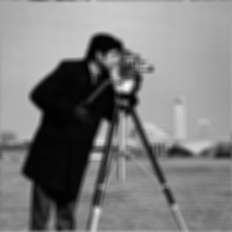 | 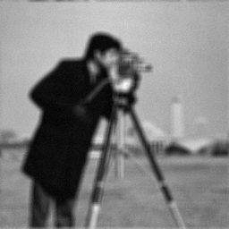 | 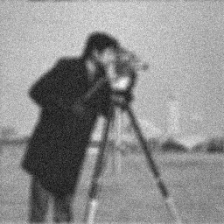
Inverse Filtered Images |  |  | 
Wiener Filtered Images | 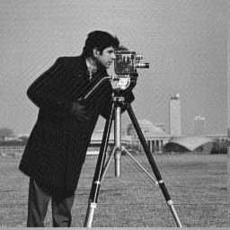 | 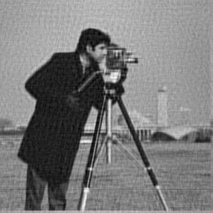 | 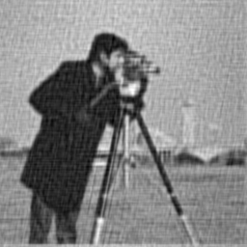
Original Image | 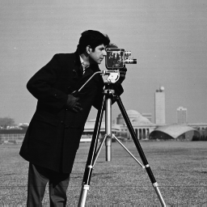

As shown, the Wiener filter performs considerable better than the inverse filter. More detail is visible in the filtered images than in the degraded ones. Notice with these images, little artifacts are visible around sharp edges in the image. Even in the presence of high noise, this image restores closely to the original, enough so, that many details are much clearer.
Finally, we present a “real world” application of the Wiener filter. An aerial photograph will be artificially degraded and examined. Then, using the Weiner filter, the image will be reconstructed.
The aerial image shown (Table 2) is degraded by an 11 x 11 Gaussian window with standard deviation of 0.9. The noise is Gaussian with unknown variance. By examining the image and the camera equipment, we can come up with a reasonable estimate of the point spread function (PSF). Thus, we will assume then we exactly know the PSF and use our the exact PSF used to blur the image for our analysis.
Looking back at the Weiner filter transfer function, there is one term in the function that deals with noise information. It is, $\frac{S_{η}(u,v)}{S_{f}(u,v)}$. In this example, the power spectrum of the noise and undegraded images are not known. But, in the case of white noise the power spectrum of the noise term is a constant (Gonzales, 1992). However, the power spectrum of the undegraded image can not be accurately approximated. To solve this dilemma, the power spectrum term is reduced to a constant, K ($K≈\frac{S_{η}(u,v)}{S_{f}(u,v)}$).
A degraded image is filtered using different K values. The experimenter empirically determines the proper K value to use. Usually, the images are visually compared to select the optimal value for K. This approach works for many different noise types and is not exclusively used for white noise. In the case of Gaussian noise, a K equal to two times the noise variance is often used for optimal filtering. Note though, using K in place of the power spectrum term will not yield the same results as knowing both the power spectrum of the noise and undegraded image. In one case, we model this information as a constant and in the ideal case, it is modeled as two matrices. By reducing this term to a constant, much information is lost. The term $\frac{S_{η}(u,v)}{S_{f}(u,v)}$ results in a M x N matrix where M and N are the height and width of the image respectively. When using the approximation $K≈\frac{S_{η}(u,v)}{S_{f}(u,v)}$, K is a scalar.
Shown below are Wiener filtered images of the aerial photograph. Notice that K=0.01 in this example provides optimal results. Below (Table 2) is a comparison of the power spectrum term using the real information and then using the approximation.
Table 2 – Degraded aerial image reconstructed using known power spectrums versus a scalar approximation. Images are degraded by a 11x11 Gaussian blur and then by additive Gaussian noise with the variances listed. Finally, difference images are presented for the scalar approximated images.
Variance / K | 0.001 | 0.01 | 0.05
Degraded Images | 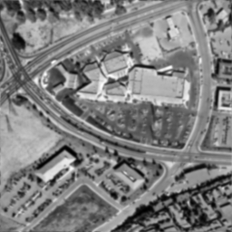 | 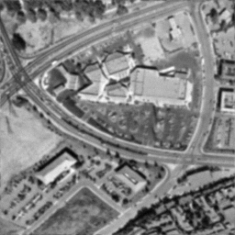 | 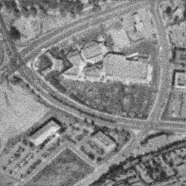
Wiener Filtered Images: $\frac{S_{η}(u,v)}{S_{f}(u,v)}$ | 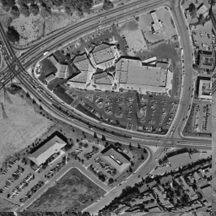 | 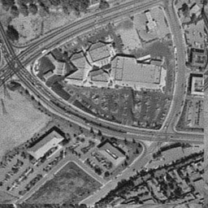 | 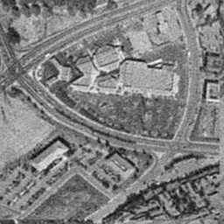
Wiener Filtered Images: $K≈\frac{S_{η}(u,v)}{S_{f}(u,v)}$ | 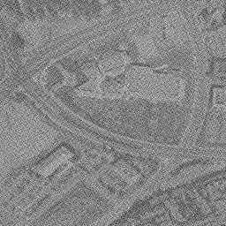 |  | 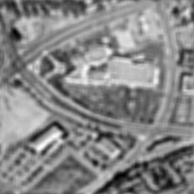
Difference Images of $K≈\frac{S_{η}(u,v)}{S_{f}(u,v)}$ with Original | 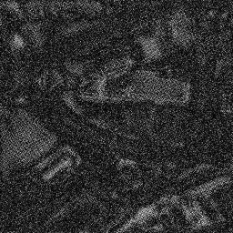 | 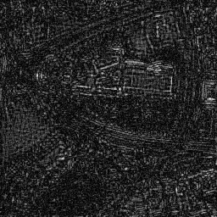 | 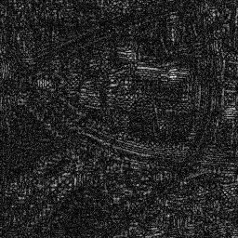
Original

It is clearly visible that the approximation does not produce results as clear as the exact.

Conclusion
In comparing our results to the example in Gonzales and Woods, our implementation of the Wiener Filter was successful. We found that, in general, knowledge of the blur function and the variance of the noise is sufficient to reasonably reconstruct the image. Our approach works well under these conditions, and is computationally efficient given the availability of an FFT algorithm. The major drawback of the algorithm is that its performance is degraded by imperfect knowledge of the blur function and noise variance. In practice, it is difficult to know both quantities perfectly, and so this approach may not be effective in some applications.
Bibliography
1. Gonzales, Rafael C. and Woods, Richard E., Digital Image Processing, Chapter 5: “Image
Restoration,” Massachusetts: Addison-Wesley Publishing, 1992.
2. Pratt, W.K., Digital Image Processing, 3rd Ed., Chapter 12: “Point and Spatial Restoration
Techniques,” New York: John Wiley and Sons, 2001.

Appendix A – Source Code
wienerfilter.m

%-------------------------------------------------------------------------------
% Wiener filter implementation
%
% Gonzalez and Woods. Digital Image Processing 2nd Edition. 263 (eqn.
% 5.8-2).
%
% wienerFilter(I, PSF, UI, N, LAMBDA)
% I Degraded Image
% PSF Point Spread Function
% UI Undegraded Image
% N Noise Image
% LAMBDA Parametric Factor
%
% Notes: This function assumes that inputs are properly zero-padded
%
%-------------------------------------------------------------------------------
function fHat = wienerFilter(I, PSF, UI, N, LAMBDA)

IPS = abs(fft2(UI)).^2;
NPS = abs(fft2(N)).^2;

% Set up equation variables
H = fft2(PSF, size(I,1), size(I,2));
HStar = conj(H);
HSquared = abs(H).^2;
G = fft2(I);

% Compute Noise to Signal Power Ratio
NSPR = LAMBDA.*(NPS ./ IPS);

% Perform filtering
den = HSquared + NSPR;
num = HStar;
FHat = num ./ den .* G;

fHat = real(ifft2(FHat));

% This line can be included to remove the circulat matrix shift done on
% the image due to the circular convolution performed by the filtering.
%
%fHat = circshift(fHat,[1.*floor(length(PSF)/2) 1.*floor(length(PSF)/2)]);

Results.m

% Script to generate results
% Type:
% Results
% to run this script.

close all;

% Image are blurred by 3 different PSF's and then additive noise is
% injected. Two types of noise is used: Gaussian and Uniform, both
% additive.

blur = {'motion'; 'gaussian'; 'average'};
noise = [0.001, 0.01, 0.05];
filename = {'images/wheel.png'; 'images/camera.png'; 'images/aerial.png'};

%_______________________________________________________________________________
% This section generates images using Gaussian Noise.

b = blur{1}
for x=1:3
I = double(imread(filename{x}));
I = I ./ 255;
PSF = Fspecial('motion', 10, -45);
for w=1:3
N = noise(w) .* randn(size(I));
D = imadd(imfilter(I, PSF, 'circular'), N);
W = wienerfilter(D, PSF, I, N, 1);
inv = inversefilter(D, PSF);
mkdir(sprintf('%s_gaussian_noise/', filename{x}));
D = (D + ones(size(D))*-min(min(D))) ./ (max(max(D + ones(size(D))*-min(min(D)))));
W = (W + ones(size(W))*-min(min(W))) ./ (max(max(W + ones(size(W))*-min(min(W)))));
inv = (inv + ones(size(inv))*-min(min(inv))) ./ (max(max(inv + ones(size(inv))*-min(min(inv)))));
imwrite(D, sprintf('%s_gaussian_noise/degraded_image_%s_%d.png', filename{x}, b, noise(w)*1000), 'png');
imwrite(W, sprintf('%s_gaussian_noise/Wfilter_image_%s_%d.png', filename{x}, b, noise(w)*1000), 'png');
imwrite(inv, sprintf('%s_gaussian_noise/Invfilter_image_%s_%d.png', filename{x}, b, noise(w)*1000), 'png');
end
end

b = blur{2}
for x=1:3
I = double(imread(filename{x}));
I = I ./ 255;
PSF = Fspecial('gaussian', [11 11], 0.9);
for w=1:3
N = noise(w) .* randn(size(I));
D = imadd(imfilter(I, PSF, 'circular'), N);
W = wienerfilter(D, PSF, I, N, 1);
inv = inversefilter(D, PSF);
mkdir(sprintf('%s_gaussian_noise/', filename{x}));
inv = (inv + ones(size(inv))*-min(min(inv))) ./ (max(max(inv + ones(size(inv))*-min(min(inv)))));
D = (D + ones(size(D))*-min(min(D))) ./ (max(max(D + ones(size(D))*-min(min(D)))));
W = (W + ones(size(W))*-min(min(W))) ./ (max(max(W + ones(size(W))*-min(min(W)))));
imwrite(D, sprintf('%s_gaussian_noise/degraded_image_%s_%d.png', filename{x}, b, noise(w)*1000), 'png');
imwrite(W, sprintf('%s_gaussian_noise/Wfilter_image_%s_%d.png', filename{x}, b, noise(w)*1000), 'png');
imwrite(inv, sprintf('%s_gaussian_noise/Invfilter_image_%s_%d.png', filename{x}, b, noise(w)*1000), 'png');
end
end

b = blur{3}
for x=1:3
I = double(imread(filename{x}));
I = I ./ 255;
PSF = Fspecial('average', [7 7]);
for w=1:3
N = noise(w) .* randn(size(I));
D = imadd(imfilter(I, PSF, 'circular'), N);
W = wienerfilter(D, PSF, I, N, 1);
inv = inversefilter(D, PSF);
mkdir(sprintf('%s_gaussian_noise/', filename{x}));
D = (D + ones(size(D))*-min(min(D))) ./ (max(max(D + ones(size(D))*-min(min(D)))));
W = (W + ones(size(W))*-min(min(W))) ./ (max(max(W + ones(size(W))*-min(min(W)))));
inv = (inv + ones(size(inv))*-min(min(inv))) ./ (max(max(inv + ones(size(inv))*-min(min(inv)))));
imwrite(D, sprintf('%s_gaussian_noise/degraded_image_%s_%d.png', filename{x}, b, noise(w)*1000), 'png');
imwrite(W, sprintf('%s_gaussian_noise/Wfilter_image_%s_%d.png', filename{x}, b, noise(w)*1000), 'png');
imwrite(inv, sprintf('%s_gaussian_noise/Invfilter_image_%s_%d.png', filename{x}, b, noise(w)*1000), 'png');
end
end
%_______________________________________________________________________________
% This section generates images using Uniform Noise.

b = blur{1}
for x=1:3
I = double(imread(filename{x}));
I = I ./ 255;
PSF = Fspecial('motion', 10, -45);
for w=1:3
N = noise(w) .* rand(size(I));
D = imadd(imfilter(I, PSF, 'circular'), N);
W = wienerfilter(D, PSF, I, N, 1);
inv = inversefilter(D, PSF);
mkdir(sprintf('%s_uniform_noise/', filename{x}));
D = (D + ones(size(D))*-min(min(D))) ./ (max(max(D + ones(size(D))*-min(min(D)))));
W = (W + ones(size(W))*-min(min(W))) ./ (max(max(W + ones(size(W))*-min(min(W)))));
inv = (inv + ones(size(inv))*-min(min(inv))) ./ (max(max(inv + ones(size(inv))*-min(min(inv)))));
imwrite(D, sprintf('%s_uniform_noise/degraded_image_%s_%d.png', filename{x}, b, noise(w)*1000), 'png');
imwrite(W, sprintf('%s_uniform_noise/Wfilter_image_%s_%d.png', filename{x}, b, noise(w)*1000), 'png');
imwrite(inv, sprintf('%s_uniform_noise/Invfilter_image_%s_%d.png', filename{x}, b, noise(w)*1000), 'png');
end
end

b = blur{2}
for x=1:3
I = double(imread(filename{x}));
I = I ./ 255;
PSF = Fspecial('gaussian', [11 11], 0.9);
for w=1:3
N = noise(w) .* rand(size(I));
D = imadd(imfilter(I, PSF, 'circular'), N);
W = wienerfilter(D, PSF, I, N, 1);
inv = inversefilter(D, PSF);
mkdir(sprintf('%s_uniform_noise/', filename{x}));
inv = (inv + ones(size(inv))*-min(min(inv))) ./ (max(max(inv + ones(size(inv))*-min(min(inv)))));
D = (D + ones(size(D))*-min(min(D))) ./ (max(max(D + ones(size(D))*-min(min(D)))));
W = (W + ones(size(W))*-min(min(W))) ./ (max(max(W + ones(size(W))*-min(min(W)))));
imwrite(D, sprintf('%s_uniform_noise/degraded_image_%s_%d.png', filename{x}, b, noise(w)*1000), 'png');
imwrite(W, sprintf('%s_uniform_noise/Wfilter_image_%s_%d.png', filename{x}, b, noise(w)*1000), 'png');
imwrite(inv, sprintf('%s_uniform_noise/Invfilter_image_%s_%d.png', filename{x}, b, noise(w)*1000), 'png');
end
end

b = blur{3}
for x=1:3
I = double(imread(filename{x}));
I = I ./ 255;
PSF = Fspecial('average', [7 7]);
for w=1:3
N = noise(w) .* rand(size(I));
D = imadd(imfilter(I, PSF, 'circular'), N);
W = wienerfilter(D, PSF, I, N, 1);
inv = inversefilter(D, PSF);
mkdir(sprintf('%s_uniform_noise/', filename{x}));
D = (D + ones(size(D))*-min(min(D))) ./ (max(max(D + ones(size(D))*-min(min(D)))));
W = (W + ones(size(W))*-min(min(W))) ./ (max(max(W + ones(size(W))*-min(min(W)))));
inv = (inv + ones(size(inv))*-min(min(inv))) ./ (max(max(inv + ones(size(inv))*-min(min(inv)))));
imwrite(D, sprintf('%s_uniform_noise/degraded_image_%s_%d.png', filename{x}, b, noise(w)*1000), 'png');
imwrite(W, sprintf('%s_uniform_noise/Wfilter_image_%s_%d.png', filename{x}, b, noise(w)*1000), 'png');
imwrite(inv, sprintf('%s_uniform_noise/Invfilter_image_%s_%d.png', filename{x}, b, noise(w)*1000), 'png');
end
end
%_______________________________________________________________________________

